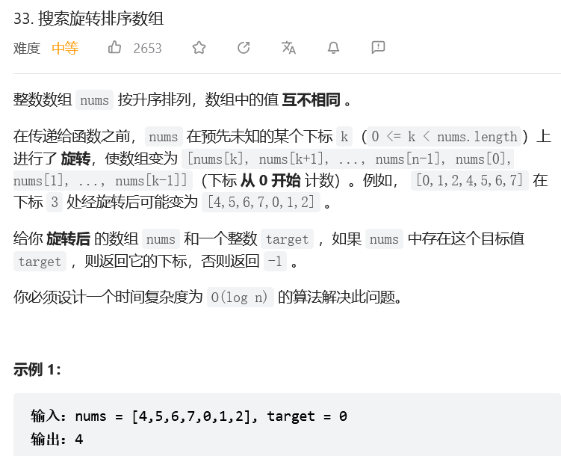
二分法：
class Solution:
def search(self, nums: List[int], target: int) -> int:
def is_blue(i: int) -> bool:
end = nums[-1]
if nums[i] > end:
return target > end and nums[i] >= target
else:
return target > end or nums[i] >= target

left, right = -1, len(nums) # 开区间 (-1, n)
while left + 1 < right: # 开区间不为空
mid = (left + right) // 2
if is_blue(mid): # 蓝色
right = mid
else: # 红色
left = mid
return right if right < len(nums) and nums[right] == target else -1
